

Advisor:

Prof. Nir Davidson

מנחה:

פרופ' ניר דודזון

Research Proposal for a Master of Science Thesis

מאת

בועז רז

תכנית מחקר לעבודת גמר

**לקראת תואר מוסמך למדעים**

By

**Boaz Raz**

תשרי תשע"ז

October 2017

**Introduction**

תערובת בוזה-פרמי מנוונת קוונטית במלכודת הרמונית מגנטית

Quantum Degenerate Bose and Fermi Gases in a Harmonic Magnetic Trap

Cold atoms are a field of study, where atomic or molecular gasses at temperatures of nano to micro Kelvins are considered. These systems, as well as being very interesting by themselves for the use in quantum computation and quantum information, are also especially interesting for the communities of condensed matter and high energy physics, due to their ability to act as a simulator for computationally hard problems in those fields. The first experimental observation of a Bose-Einstein Condensation (BEC) on 1995 [1,2], awarded a Nobel Prize on 2001. Since then, many breakthrough experiments were done, including Superfluidity [3], atomic clocks [4,5], BCS-BEC cross-over [6], Topological order and quantum computation [7], Fractional quantum Hall states [8], Hubbard models to serve as quantum simulators [9], as well as several other simulations done with cold atoms in optical lattices [10,11].

While nowadays it is relatively easy to cool down bosons to sub micro Kelvin temperatures, the same is not largely true for fermions, because fermions tend to stay away from each other due to Pauli Exclusion Principle. Since fermions are important in some of the cold atoms experiments mentioned above, as well as in fermionic superfluidity [12] and molecular BEC [13], several techniques were developed in order to overcome the barrier for making a Degenerate Fermi Gas (DFG). Among the techniques one can find sympathetic cooling with a bosonic BEC [14] and exploiting of Feshbach [15,16] resonances to increase fermions interaction strength.

**Research objective**

Our purpose is to achieve a quantum degenerate Bose-Fermi mixture, and to perform several experiments, such as observing fermion mediated interaction between bosons.

Detailed description of the proposed research

We have built an apparatus for cooling and trapping $^{87}Rb$ bosons, and $^{40}K$ fermions. The atoms are captured using a 3D Magneto-Optical Trapping method (MOT), which is then compressed and further cooled using Polarization Gradient Cooling (PGC). Using an adiabatic magnetic transport, made of a series of pairs of coils in an L shape, the atoms are then moved to a final chamber, where the pressure drops down to Ultra High Vacuum (UHV) regime. In here, the technique used for cooling the gasses below the micro Kelvin threshold is evaporating the hot atoms out of the ensemble, letting the cloud thermalize and reach ever lower temperatures, at the cost of losing some of the atoms in the process. The technique is very efficient for bosons, which cool down to the point where a BEC is formed. This, however, is not the case for fermions, since Pauli blocking will cease the atoms from interacting, and the cloud from thermalizing. This hurdle can be overcome by sympathetically cooling a cloud of fermions in thermal contact with the bosons, reportedly reaching temperatures as low as $0.2$ of the Fermi temperature [17,18,19] – reaching a fermi degenerate gas.

The gasses are trapped using a magnetic field, which interact with the atoms spin and exerts forces on them. [20,21] The force can be either restoring or repulsive, depending on the orientation of the spin moment relative to the field. We use a Quadrupole trap, and the area near the minima where the atoms are being trapped has zero magnetic fields, and a Majorana spin flip can occur [22]. This will cause a trapped atom to be pushed outside the trap, resulting in a significant loss of atoms. The colder the atom cloud gets, the denser it is near the center, and the atoms will be lost faster [23]. In order to avoid these losses, we present a method attempting to raise the minima of the magnetic field to some controllable finite value. The method introduce an additional Pritchard-Ioffe coil, to join the two already existing Quadrupole coils in Anti-Helmholtz configuration, forming a magnetic trap called QUIC, [24,25,26,27] which has a biased minima along the Y axis, as depicted in Figure 1. The Quadrupole coils of the trap also serve as the last pair of coils in the magnetic transport, and the Pritchard-Ioffe coil is mounted at a controllable distance from the center of the Quadrupole trap. When the atoms reach the final pair of coils of the magnetic transport, the third coil is then adiabatically turned on in order to avoid heating of the atoms due to sudden change in the potential. Only then, will the evaporation and thermalization process of the fermions begin, reaching a fraction of the Fermi temperature, resulting in a DFG.

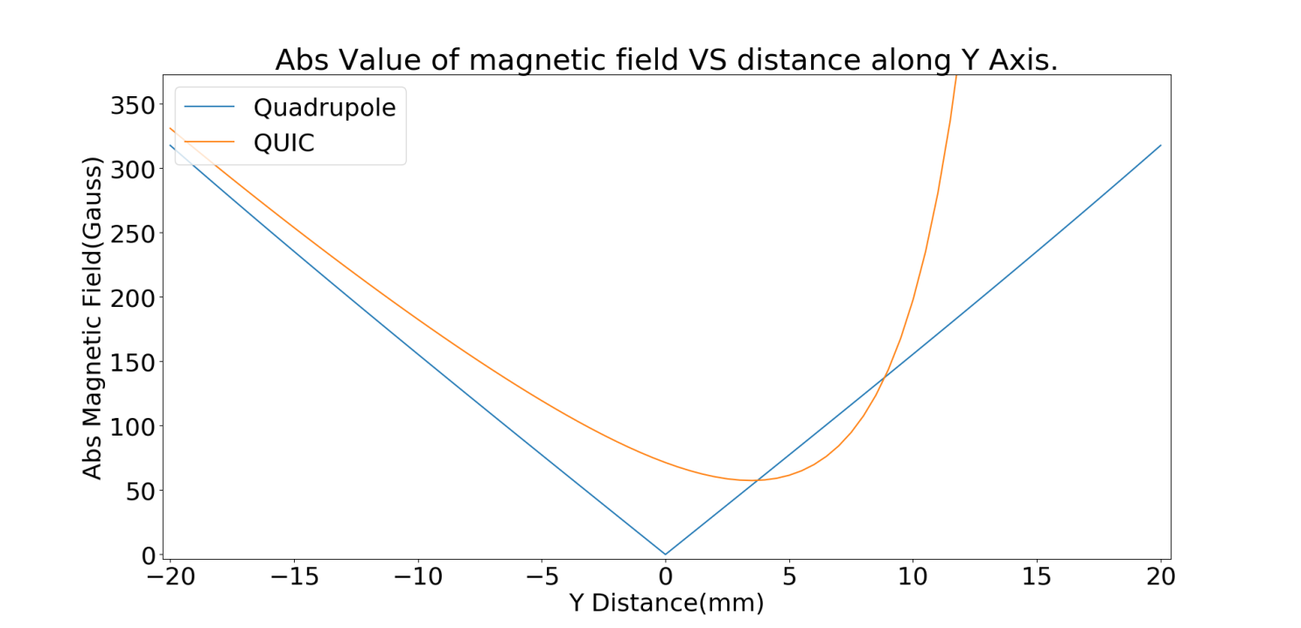

Figure : Simulation of the absolute magnetic field along the Y axis as defined in Blue: Quadrupole trap. Orange: QUIC trap. It can be seen that the minima of the QUIC trap has a finite bias, is moved along the Y axis, and the shape is changed.

Our simulation of the resulting trap shows that, moving the Pritchard-Ioffe coil along the Y axis, we can control the location, bias and frequency of the trap. In order to further move the bias of the minima, an additional constant magnetic field can be applied using a pair of bias coils in Helmholtz configuration along the Y axis.

After reaching a state of a DFG, we will have a Fermi sea coupled to a cloud of bosons. The fermions will not be able to interact with each other due to Pauli blocking, but they can interact with the bosons. When a fermion interact with a boson, it is excited, and a fermion-hole pair is formed. After some time, the pair will scatter from another boson, and the fermion will return to its original state, leaving the Fermi Sea unchanged. This can act as an effective potential for interaction between bosons, mediated by the fermions. In condensed matter systems this is called an RKKY interaction [28,29]. We intend to measure the dynamics of the bosons due to the mediated interaction of the fermions, similar to what is proposed in [30]. We hope to find evidence of these interactions by measuring collisional frequency shifts.

References

x

|  |  |
| --- | --- |
| [1] | Mike H., Jason R. Ensher, Michael R. Matthews, Carl E. Wieman, and Eric A. Cornell. Anderson, "Observation of Bose-Einstein condensation in a dilute atomic vapor," *science* , vol. 5221 , no. 269, pp. 198-201, 1995. |
| [2] | Kendall B., M-O. Mewes, Michael R. Andrews, N. J. Van Druten, D. S. Durfee, D. M. Kurn, and Wolfgang Ketterle. Davis, "Bose-Einstein condensation in a gas of sodium atoms," *Physical review letters*, vol. 75, no. 22 , p. 3969, 1995. |
| [3] | Markus, Olaf Mandel, Tilman Esslinger, Theodor W. Hänsch, and Immanuel Bloch. Greiner, "Quantum phase transition from a superfluid to a Mott insulator in a gas of ultracold atoms.," *nature* , vol. 6867 , no. 415, pp. 39-44., 2002. |
| [4] | Guido, Tomas Binnewies, Carsten Degenhardt, Uwe Sterr, Jürgen Helmcke, and Fritz Riehle. Wilpers, "Optical clock with ultracold neutral atoms," *Physical review letters* , vol. 89, no. 23 , p. 230801, 2002. |
| [5] | Masao, Hong Feng-Lei, Ryoichi Higashi, and Hidetoshi Katori. Takamoto, "An optical lattice clock.," *Nature* , vol. 435, no. 7040 , p. 321, 2005. |
| [6] | C. A., Markus Greiner, and Deborah S. Jin. Regal, "Observation of resonance condensation of fermionic atom pairs.," *Physical review letters* , vol. 92, no. 4, p. 040403, 2004. |
| [7] | A André et al., "A coherent all-electrical interface between polar molecules and mesoscopic superconducting resonators," *Nature Physics*, vol. 2, no. 9, pp. 636-642, 2006. |
| [8] | Nigel R., Nicola K. Wilkin, and J. M. F. Gunn Cooper, "Quantum phases of vortices in rotating Bose-Einstein condensates," *Physical review letters*, vol. 87, no. 12, p. 120405, 2001. |
| [9] | D. Zoller, P. Jaksch, "The cold atom Hubbard toolbox," *Annals of Physics*, vol. 315, no. 1, pp. 52-79, 2005. |
| [10] | Dieter, Ch Bruder, Juan Ignacio Cirac, Crispin W. Gardiner, and Peter Zoller. Jaksch, "Cold bosonic atoms in optical lattices," *Physical Review Letters*, vol. 81, no. 15 , p. 3108, 1998. |
| [11] | David. DeMille, "Quantum computation with trapped polar molecules.," *Physical Review Letters*, vol. 88, no. 6, p. 067901, 2002. |
| [12] | K. M., S. L. Hemmer, M. E. Gehm, S. R. Granade, and J. E. Thomas. O'hara, "Observation of a strongly interacting degenerate Fermi gas of atoms.," *Science* , vol. 5601 , no. 298, pp. 2179-2182., 2002. |
| [13] | Martin W., Claudiu A. Stan, Christian H. Schunck, Sebastian MF Raupach, Subhadeep Gupta, Zoran Hadzibabic, and Wolfgang Ketterle. Zwierlein, "Observation of Bose-Einstein condensation of molecules.," *Physical review letters*, vol. 91, no. 25 , p. 250401, 2003. |
| [14] | B. J., Krutik Patel, Jacob Johansen, and Cheng Chin. DeSalvo, "Observation of a Degenerate Fermi Gas Trapped by a Bose-Einstein Condensate," *arXiv preprint*, vol. 1706, no. 01220 , 2017. |
| [15] | M. W., C. A. Stan, C. H. Schunck, S. M. F. Raupach, A. J. Kerman, and W. Ketterle. "Zwierlein, "Condensation of pairs of fermionic atoms near a Feshbach resonance.," *Physical Review Letters*, vol. 92, no. 12 , p. 120403, 2004. |
| [16] | Cheng, Rudolf Grimm, Paul Julienne, and Eite Tiesinga. Chin, "Feshbach resonances in ultracold gases.," *Reviews of Modern Physics* , vol. 82, no. 2, p. 1225, 2010. |
| [17] | Giovanni, Gabriele Ferrari, Giacomo Roati, Robert J. Brecha, A. Simoni, and Massimo Inguscio. Modugno, "Bose-Einstein condensation of potassium atoms by sympathetic cooling," *Science* , vol. 294, no. 5545 , pp. 1320-1322, 2001. |
| [18] | Z., C. A. Stan, K. Dieckmann, S. Gupta, M. W. Zwierlein, A. Görlitz, and W. Ketterle. Hadzibabic, "Two-species mixture of quantum degenerate Bose and Fermi gases," *Physical review letters*, vol. 88, no. 16 , p. 160401, 2002. |
| [19] | Meng Khoon, Simon Stellmer, Rudolf Grimm, and Florian Schreck. Tey, "Double-degenerate Bose-Fermi mixture of strontium.," *Physical Review A*, vol. 82, no. 1, p. 011608, 2010. |
| [20] | T., Gidon Erez, and Harold J. Metcalf. Bergeman, "Magnetostatic trapping fields for neutral atoms," *Physical Review A*, vol. 35, no. 4, p. 1535, 1987. |
| [21] | David E. Pritchard, "Cooling neutral atoms in a magnetic trap for precision spectroscopy.," *Physical Review Letters*, vol. 51, no. 15 , p. 1336, 1983. |
| [22] | Wolfgang, Michael H. Anderson, Jason R. Ensher, and Eric A. Cornell. Petrich, "Stable, tightly confining magnetic trap for evaporative cooling of neutral atoms," *Physical Review Letters*, vol. 74, no. 17 , p. 3352, 1995. |
| [23] | T. H., Patrick McNicholl, Jan Kycia, Harold Metcalf, and N. L. Balazs. Bergeman, "Quantized motion of atoms in a quadrupole magnetostatic trap.," *JOSA B* , vol. 6, no. 11, pp. 2249-2256., 1989. |
| [24] | Tilman, Immanuel Bloch, and Theodor W. Hänsch. Esslinger, "Bose-Einstein condensation in a quadrupole-Ioffe-configuration trap.," *Physical Review A*, vol. 58, no. 4, p. R2664, 1998. |
| [25] | Robert LD, Robert P. Smith, Naaman Tammuz, Scott Beattie, Stuart Moulder, and Zoran Hadzibabic. Campbell, "Efficient production of large K 39 Bose-Einstein condensates," *Physical Review A*, vol. 82, no. 6, p. 063611, 2010. |
| [26] | C., T. Henninger, J. Will, W. Ertmer, and J. Arlt. Klempt, "Transport of a quantum degenerate heteronuclear Bose-Fermi mixture in a harmonic trap," *The European Physical Journal D*, vol. 48, no. 1, pp. 121-126, 2008. |
| [27] | Xiong, Chen Hai-Xia, Wang Peng-Jun, Yu Xu-Dong, Gao Feng, and Zhang Jing. De-Zhi, "Quantum degenerate Fermi–Bose mixtures of 40K and 87Rb atoms in a quadrupole-Ioffe configuration trap.," *Chinese Physics Letters*, vol. 25, no. 3, p. 843, 2008. |
| [28] | M. A. and Kittel, C. Ruderman, "Indirect Exchange Coupling of Nuclear Magnetic Moments by Conduction Electrons," *Phys. Rev.*, vol. 96, no. 1, pp. 99-102, 1954. |
| [29] | S. Sorella and E. Tosatti, "Semi-Metal-Insulator Transition of the Hubbard Model in the Honeycomb Lattice," *EPL (Europhysics Letters)*, vol. 19, p. 699, 1992. |
| [30] | S., and I. B. Spielman. De, "Fermion-mediated long-range interactions between bosons stored in an optical lattice," *Applied Physics B*, vol. 114, no. 4, pp. 527-536., 2014. |
| [31] | Jee Woo, Cheng-Hsun Wu, Ibon Santiago, Tobias G. Tiecke, Sebastian Will, Peyman Ahmadi, and Martin W. Zwierlein. Park, "Quantum degenerate Bose-Fermi mixture of chemically different atomic species with widely tunable interactions," *Physical Review A*, p. 051602, 2012. |
| [32] | Brian, and Deborah S. Jin. DeMarco, "Onset of Fermi degeneracy in a trapped atomic gas , no. (): ," *Science*, vol. 285, no. 5434, pp. 1703-1706, 1999. |

x